CONFIGURACION DE UNA RED INSTITUCIONAL CON VLAN

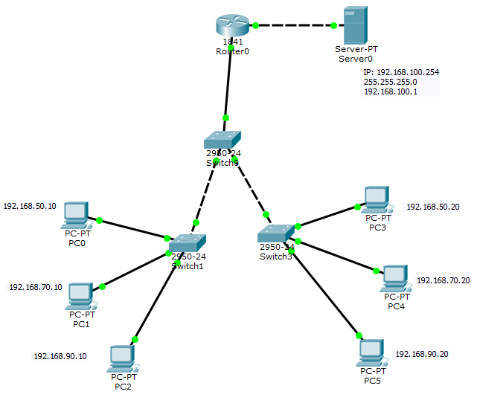
PRIMER SWITCH
Switch>enable
Switch#conf ter
Enter configuration commands, one per line. End with CNTL/Z.
Switch(config)#vlan 50
Switch(config-vlan)#name FC
Switch(config-vlan)#vlan 70
Switch(config-vlan)#name FCL
Switch(config-vlan)#vlan 90
Switch(config-vlan)#name FCIS
Switch(config-vlan)#EXIT
Switch(config)#int rang fa0/1-4
Switch(config-if-range)#sw mode trunk
Switch(config-if-range)#exit
Switch(config)#exit
Switch#
%SYS-5-CONFIG_I: Configured from console by console

Switch#sh vlan brief

SEGUNDO SWITCH

Switch>enable
Switch#conf ter
Enter configuration commands, one per line. End with CNTL/Z.
Switch(config)#VLAN 50
Switch(config-vlan)#name FC
Switch(config-vlan)#VLAN 70
Switch(config-vlan)#name FCL
Switch(config-vlan)#VLAN 90
Switch(config-vlan)#VLAN FCIS
^
% Invalid input detected at '^' marker.
Switch(config-vlan)#name FCIS
Switch(config-vlan)#exit
Switch(config)#int rang fa0/1-5
Switch(config-if-range)#sw mode access
Switch(config-if-range)#sw access VLAN 50
Switch(config-if-range)#int rang fa0/6-10
Switch(config-if-range)#sw mode access
Switch(config-if-range)#sw access VLAN 70
Switch(config-if-range)#int rang fa0/11-23
Switch(config-if-range)#sw mode access
Switch(config-if-range)#sw access VLAN 90
Switch(config-if-range)#EXIT
Switch(config)#int fa0/24
Switch(config-if)#sw mode trunk
Switch(config-if)#exit
Switch(config)#exit
Switch#
%SYS-5-CONFIG_I: Configured from console by console

Switch#sh vlan bief

TERCER SWITCH
Switch>enable
Switch#conf ter
Enter configuration commands, one per line. End with CNTL/Z.
Switch(config)#VLAN 50
Switch(config-vlan)#name FC
Switch(config-vlan)#VLAN 70
Switch(config-vlan)#name FCL
Switch(config-vlan)#VLAN 90
Switch(config-vlan)#name FCIS
Switch(config-vlan)#exit
Switch(config)#int rang fa0/1-5
Switch(config-if-range)#sw mode access
Switch(config-if-range)#sw access VLAN 50
Switch(config-if-range)#int rang fa0/6-10
Switch(config-if-range)#sw mode access
Switch(config-if-range)#sw access VLAN 70
Switch(config-if-range)#int rang fa0/11-23
Switch(config-if-range)#sw mode access
Switch(config-if-range)#sw access VLAN 90
Switch(config-if-range)#exit
Switch(config)#int fa0/24
Switch(config-if)#sw mode trunk
Switch(config-if)#exit
Switch(config)#exit
Switch#
%SYS-5-CONFIG_I: Configured from console by console

Switch#sh vlan brief

ROUTER
Router>enable
Router#conf ter
Enter configuration commands, one per line. End with CNTL/Z.
Router(config)#int fa0/0.1
Router(config-subif)#encapsulation dot1q 50
Router(config-subif)#ip address 192.168.50.1 255.255.255.0
Router(config-subif)#exit
Router(config)#int fa0/0.2
Router(config-subif)#encapsulation dot1q 70
Router(config-subif)#ip address 192.168.70.1 255.255.255.0
Router(config-subif)#int fa0/0.3
Router(config-subif)#encapsulation dot1q 90
Router(config-subif)#ip address 192.168.90.1 255.255.255.0
Router(config-subif)#exit
Router(config)#int fa0/0
Router(config-if)#no shutdown
Router(config-if)#exit
Router(config)#exit
Router#
%SYS-5-CONFIG_I: Configured from console by console

Router#copy running-config startup-config
Destination filename [startup-config]?
Building configuration...
[OK]

PARA SERVIDOR
Router#conf ter
Enter configuration commands, one per line. End with CNTL/Z.
Router(config)#int fa0/1
Router(config-if)#ip address 192.168.100.1 255.255.255.0
Router(config-if)#no shutdown

Router(config-if)#
%LINK-5-CHANGED: Interface FastEthernet0/1, changed state to up

Router(config-if)#exit
Router(config)#ip dhcp pool FC
Router(dhcp-config)#network 192.168.50.0 255.255.255.0
Router(dhcp-config)#default-router 192.168.10.1
Router(dhcp-config)#dns-server 192.168.100.254
Router(dhcp-config)#exit
Router(config)#ip dhcp pool FCL
Router(dhcp-config)#network 192.168.70.0 255.255.255.0
Router(dhcp-config)#default-router 192.168.70.1
Router(dhcp-config)#dns-server 192.168.100.254
Router(dhcp-config)#exit
Router(config)#ip dhcp pool FCIS
Router(dhcp-config)#network 192.168.90.0 255.255.255.0
Router(dhcp-config)#default-router 192.168.90.1
Router(dhcp-config)#dns-server 192.168.100.254
Router(dhcp-config)#EXIT
Router(config)#EXIT
Router#
%SYS-5-CONFIG_I: Configured from console by console

Router#copy running-config startup-config
Destination filename [startup-config]?
Building configuration...
[OK]
Router#exit

